

Task 2 – Credit Submission

Student Number: Truong Ngoc Gia Hieu
Student Name (VietNam/Australia): SWS01217/ 105565520

Task Credit2a
First and foremost, I had to download a file named Cust_Details.xlsx. In detail, the file contains two sheet named Sheet1 and Sheet2. After that, I opened both sheets in Microsoft Access as two tables and changed table name to CUST5520 and CUST_TYPE5520 respectively.
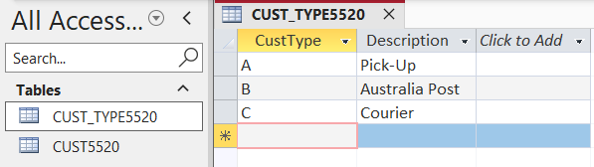

Figure 1: Data of CUST_TYPE5520 Table (Datasheet View).
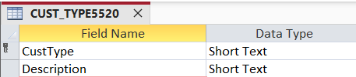

Figure 2: Design View of CUST_TYPE5520 Table.
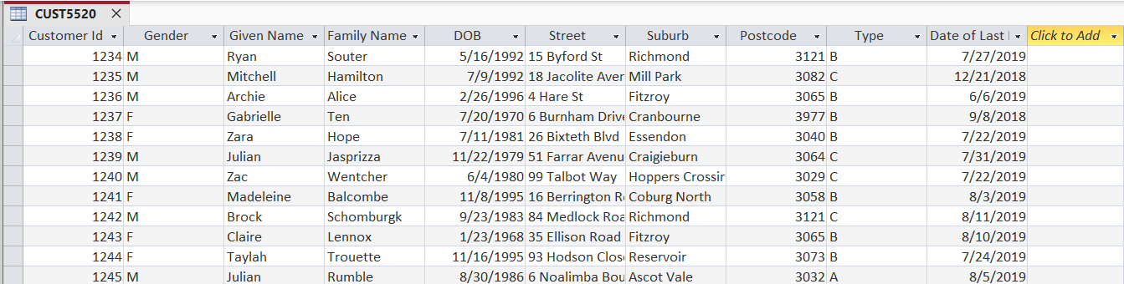
Figure 3: Data of CUST5520 Table (Datasheet View).

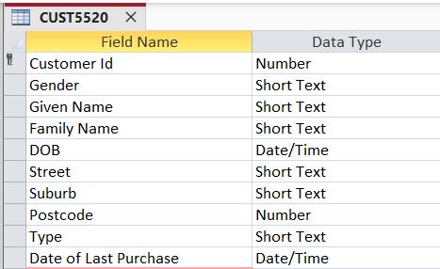
Figure 4: Design View of CUST5520 Table.
After renaming the two tables above, I established relationships between them based on Primary Key and Foreign Key. Based on the Design View of the two tables, I decided to link CustType (Primary Key) field in the CUST_TYPE5520 table with Type (Foreign Key) field in the CUST5520 table.
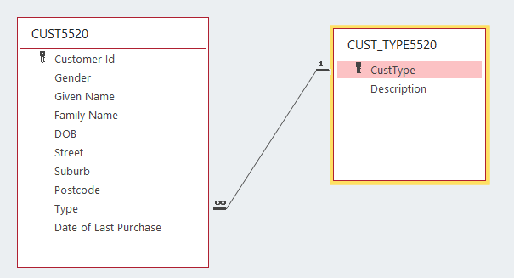
Figure 5: Relationship between CUST5520 and CUST_TYPE5520 Tables.
It is clear that one CustType can have many records/rows of Type in the CUST5520 table, and one record in the CUST5520 table corresponds to only one specific CustType in the CUST_TYPE5520 table, establishing a one-to-many relationship.

Task Credit2b
The sfunction yntax of the DateDiff in Microsoft Access is:
DateDiff(interval, date1, date2[, firstdayofweek][, firstweekofyear])
- interval (mandatory): the time unit to use for calculating the distance (enclosed in quotation marks), including 'yyyy', 'q', 'm', and so on.
- date1 and date2 (mandatory): two timestamps to compare. If 'date1' is greater than 'date2', the function returns a negative value.
- firstdayofweek (Optional): defines the first day of the week (Default: Sunday, which means 1).
- firstweekofyear (Optional): defines the first week of the year (Default: the week containing January 1st, which means 1).
In terms of calculating the age of customer, the method is to subtract the customer’s birth year from current year. Subsequently, the formula for the Age column is:
Age: DateDiff("yyyy",[DOB],Now())
In the above formula, I created a new column named Age first. In detail, the "yyyy" parameter requires Access to calculate the difference based on years, [DOB] is the date of birth field, and Now() retrieves the current system date.
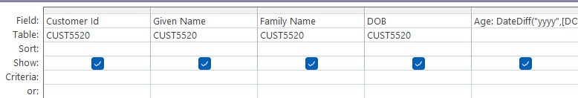
Figure 6: Design View of T2CB_5520 Query.
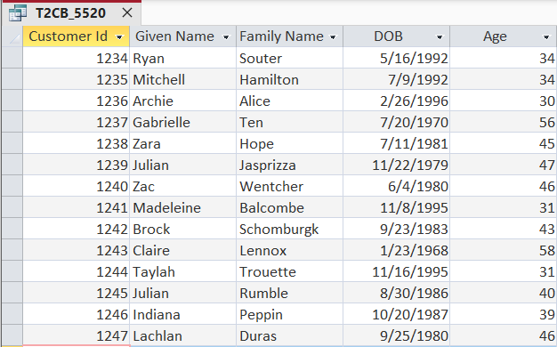
After completing the design grid of the query named T2CB_5520, I clicked the Run button to view the results.

Figure 7: Datasheet View of T2CB_5520 Query Results.
Settings | Description
yyyy | Year
q | Quarter
m | Month
y | Day of the year
d | Day
w | Weekday
ww | Week
h | Hour
n | Minute
s | Second

Figure 8: DateDiff Interval Settings.
Constant | Value | Description
vbUseSystem | 0 | Use NLS API settings.
vbSunday | 1 | Sunday
vbMonday | 2 | Monday
vbTuesday | 3 | Tuesday
vbWednesday | 4 | Wednesday
vbThursday | 5 | Thursday
vbFriday | 6 | Friday
vbSaturday | 7 | Saturday
Figure 9: DateDiff firstdayofweek Settings.

Task Credit2c
In the Task Credit2c description, this section requires students to generate a new query named T2CC_5520 using the previous query of task Credit2b as it sources.Next, I dragged and dropped all columns from the T2CB_5520 query and filled in the Criteria row of the Age column with: ‘<= [Enter Age]’
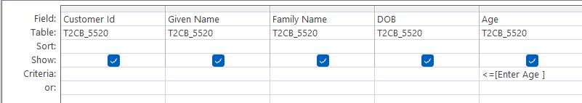
Figure 10: Design View of T2CC_5520 Parameter Query
After I clicked the Run button, a dialog box appeared, prompting me to input the age value.
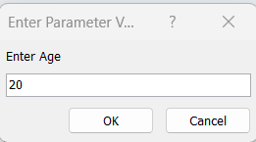
Figure 11: Input Dialog Box Prompting for Age Value
As a result, the query searched customers whose age is equal to or less than 20 and the results were displayed in the Datasheet View.
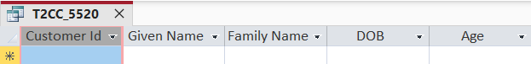
Figure 12: Datasheet View of T2CC_5520 Parameter Query Results
Based on Figure 12, it is clear that no records matched the condition of being 20 years old or less. Now, I will try filtering with a limit of 30 years old.

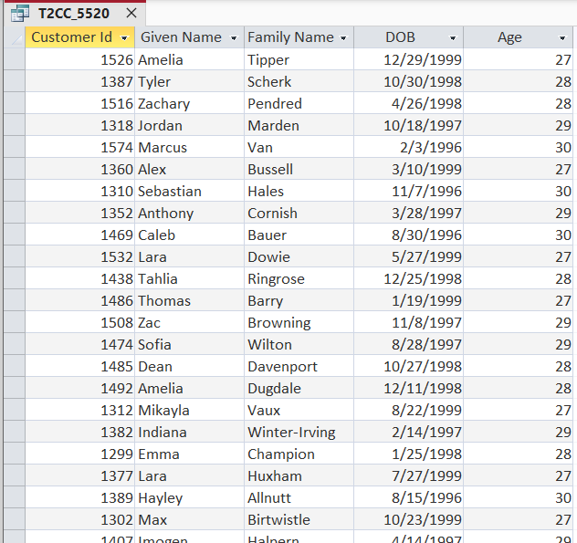
Figure 13: Datasheet View of T2CC_5520 Results with Age Limit Set to 30
After viewing data, I could say that the minimum age of custoner in the database is 27 years old.

Task Credit2d
In the fourth task, I had to use both tables CUST5520 and CUST_TYPE5520 to create a query named T2CD_5520. Next, I selected the Totals function to show the Total row and dragged and dropped the following columns into the Design Grid:
- Field: Suburb, Table: CUST5520, Total: Group By, Sort: Ascending
- Field: CustType, Table: CUST_TYPE5520, Total: Group By, Sort: Ascending
- Field: Description, Table: CUST_TYPE5520, Total: Group By, Sort: Ascending
- Field: Customer Id, Table: CUST5520, Total: Count, Sort: Descending

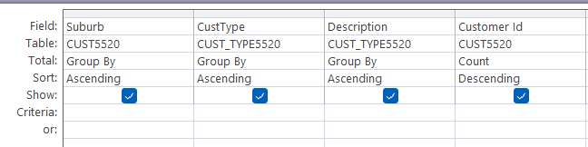
Figure 14: Design View of T2CD_5520 Query
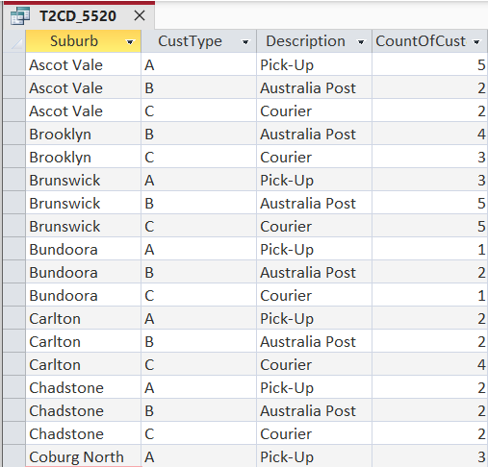

Figure 15: Datasheet View of T2CD_5520 Query

Task Credit2e
In terms of exporting to a text file named T2CD_5520.txt, I chose Text File in the External Data tab, selected the storage location, clicked Delimited (Characters such as comma or tab separate each field), ticked Include Field Names on First Row, and chose Comma as the delimiter with double quotes as the text qualifier.

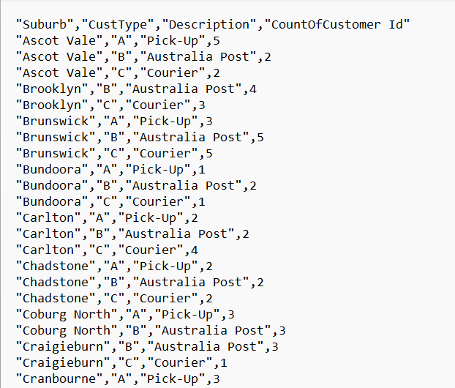
Figure 16: First 10 Rows of the Exported T2CD_5520.txt File

Task Credit2f
In the description of the task Credit2f, first and foremost, I selected the ACTOR5520 table in Data View mode. Then, I added a new column named TotalPets using the formula:
TotalPets = ACTOR5520[NoOfDogs] + ACTOR5520[NoOfCats]
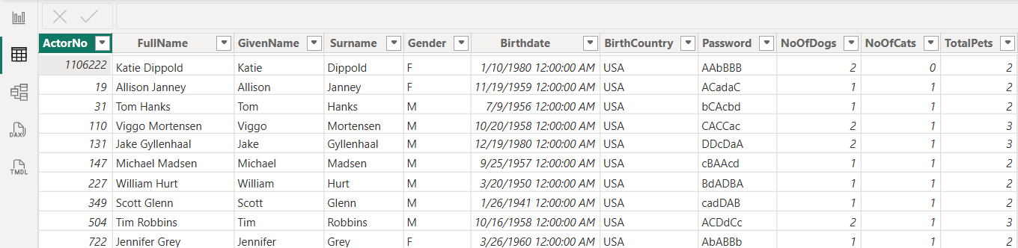
Figure 17: Data View of ACTOR5520 Table Showing the New TotalPets Column

Regarding the visualization, I decided to create two charts: a Clustered Column Chart named Total Pets by Gender and a Map named Average Pets per Country.
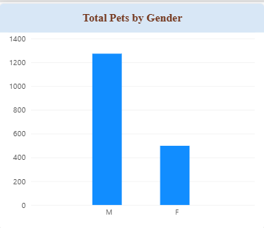
Figure 18: Clustered Column Chart Showing Total Pets by Gender
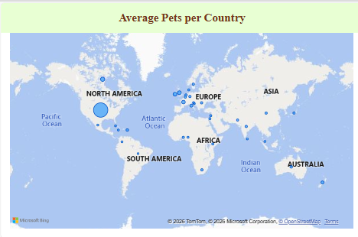
Figure 19: Map Visualization of Average Pets per Country
It can be seen from the Clustered Column Chart (Figure 18) that males have more pets, including cats and dogs, compared to females. Moreover, the distribution of pets on the map showcases that North America, particularly the United States, holds the highest concentration of actors and pet ownership while other regions across Europe, Asia, and Australia display smaller, dispersed bubbles indicating lower average pet numbers per country.

Task Credit2g
Subsequently, this task requires students to create a new column named DAYNO_5520 for calculating the day of the week based on each actor's date of birth. Then, I selected the ACTOR5520 table in Data View, added a new column, and applied the following syntax:
DAYNO_5520 = WEEKDAY(ACTOR5520[Birthdate], 1)
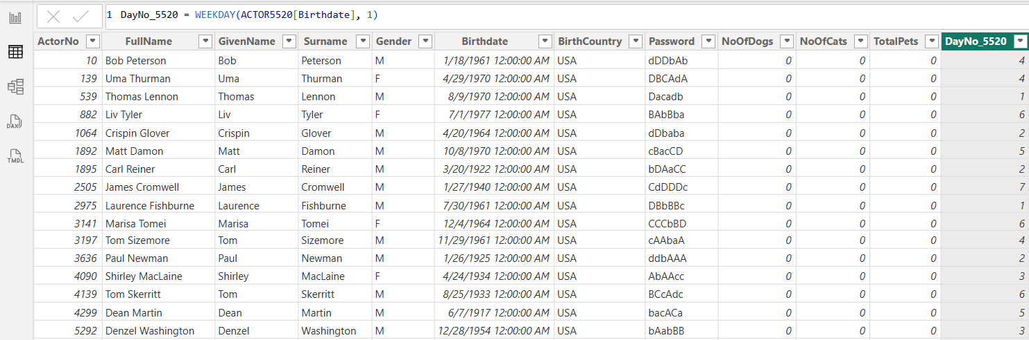
Figure 20: Data View of ACTOR5520 Table Showing the New DayNo_5520 Column
Furthermore, the task requires me to generate a donut chart. Specifically, I placed the DayNo_5520 field into the Legend and the ActorNo field into the Values to analyze the distribution. In additiion, I set title for the donurt chart is Total Actors by Birth Day Number with Font Size is 15, Color is Brown, Bold and Center Alignment.
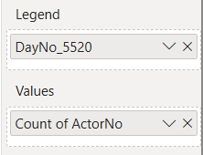
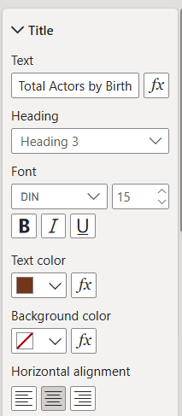
Figure 21: Build Visual and General Configuration

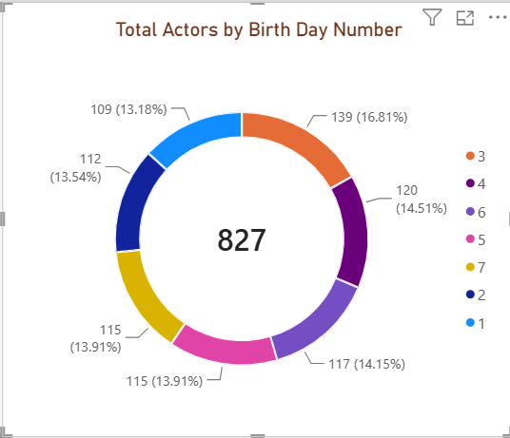
Figure 22: Total Actors by Birth Day Number Chart

Task Credit2h
First and foremost, I switched to Data View mode and clicked Enter Data on the Home tab, which opened the Create Table dialog box. Then, I entered DayNo_5520 for Column1 and DayName for Column2. Next, I populated the rows with values ranging from 1 (Sunday) to 7 (Saturday) respectively. After that, I clicked on Load button and renamed table to WeekDays5520
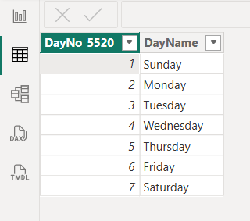
Figure 23: Data View of the WeekDays5520 Table

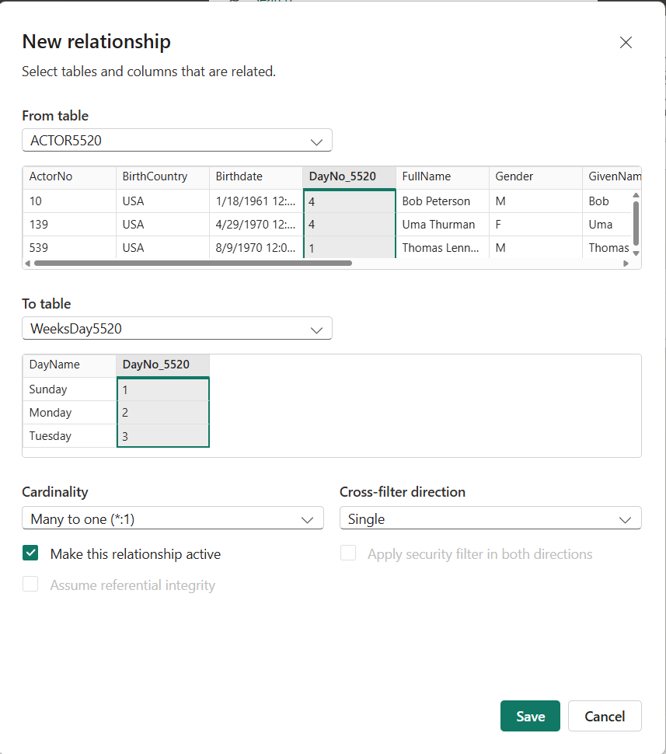
Figure 24: New Relationship Dialog Box between ACTOR5520 and WeeksDay5520

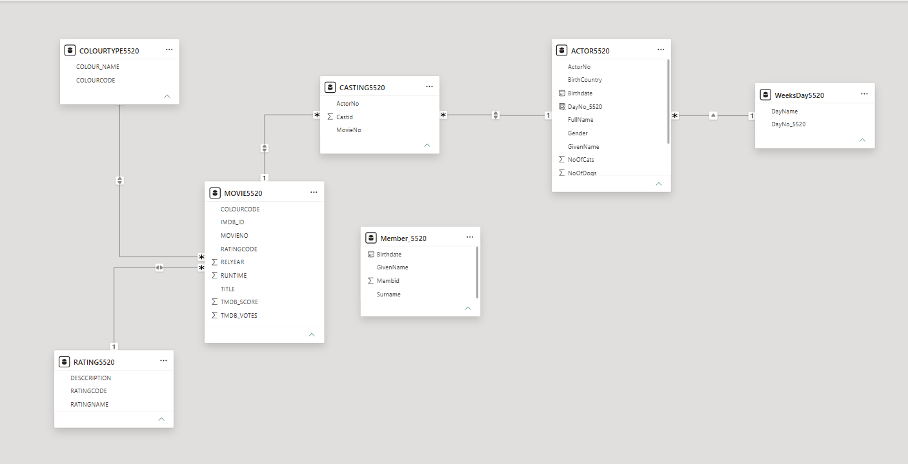
Figure 25: Relationships View of the Database Model

Task Credit2i
In Task 2i, I was required to create a pie chart to showcase the relationship between actors and their birth day names, illustrating the distribution of the Count of actors by Birth DayName. Additionally, I placed the DayName field into the Legend and Count of ActorNo into the Values, set the chart title to Total Actors by Birth Day Name, and applied styling consistent with the previous charts.
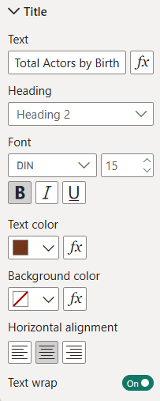
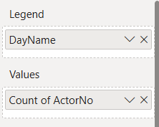

Figure 26: Build Visual and Format Visual Configuration for the Pie Chart

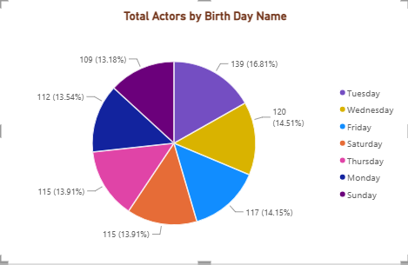
Figure 27: Pie Chart Showing Total Actors by Birth Day Name

Task Credit2j
In the final task of the Credit section, I added a Slicer visualization using the DayName field from the WeeksDay5520 table and titled it Filter by Day Name. Therefore, this interactive slicer allows users to filter the entire dashboard by specific days of the week, seamlessly integrating all four visual elements for dynamic data analysis.
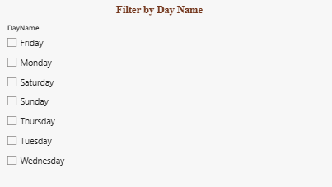
Figure 28: Slicer for filtering data by Day Name
Finally, I added a new Text Box containing my full name (Truong Ngoc Gia Hieu), student ID (105565520), and a brief description of the report's purpose and interactive features which ensures all individual identification and documentation requirements are fully met on the dashboard.

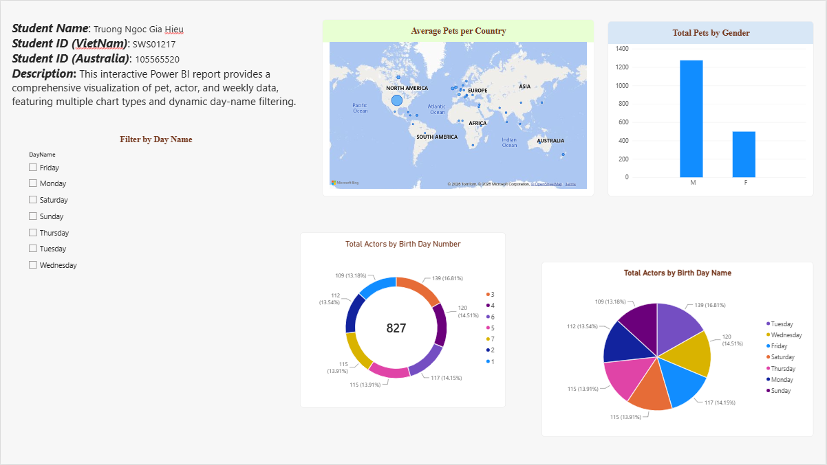
Figure 29: Final Power BI Report Dashboard

Conclusion
In this report, a comprehensive and interactive Power BI dashboard was successfully developed. By integrating multiple visual types (bar chart, map, donut chart, and pie chart), a dynamic day-name slicer, and personalized student details, the report effectively demonstrates advanced data visualization and analysis techniques.

